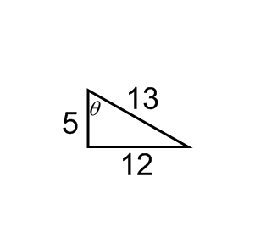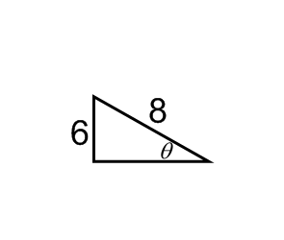HW 9-2 Name_________________________________________

Secondary Math 3 Period_________

Find all the values of the six trigonometric functions of the angle  .

1. 2.

**Find the measure of the indicated angle to the nearest degree.**

3. 4.

x

x

42

40

38

27

5. 6.

23

21

x

x

29

14

**Solve the right triangle. Round to the nearest tenth.**

A

7. 8.

*r*

P

Q

R

*p*

13



11

18

*b*

C

B

   

4

5.9

*m*

L

M

K

*z*

8.5



x

Y

X

Z

9. 10.

   

11. What is the reciprocal of sine? cosine? tangent?

12. You are hiking up a mountain peak. You begin hiking at a trailhead. The trail ends near the summit at 14,255 ft. The horizontal distance between these two points is about 17,625 feet. Estimate the angle of elevation from the trailhead to the summit. Round your answer to the nearest tenth.

Horizontal distance 17,625 ft

14,255 ft

summit

trailhead

13. During its approach to Earth, the space shuttle’s glide angle changes. When the space shuttle is 5 miles from the runway, its glide angle is about 19 degrees. Find the shuttle’s altitude at this point in its descent. Round your answer to the nearest tenth.

altitude

distance to runway

runway

glide angle