HW 9-3 Name _____________________________________

Period____________

Find the missing side lengths for each triangle.

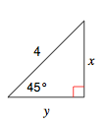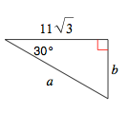

1. 2.

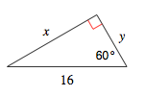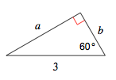

3. 4.

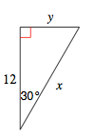

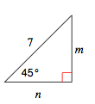5. 6.

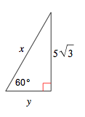7. 8.

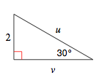

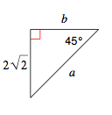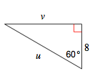

9. 10.