Math Secondary III Name_____________________________________

4-1 Complex Operations Period__________

**Write each expression as a pure imaginary number.**

1.  2.  3.  4. 

**Identify the real and imaginary parts of each complex number.**

5.  6.  7.  8. 

**Write each expression as a complex number in standard form (a+bi).**

9.  10.  11.  12. 

**Add or subtract as indicated. Write answers in standard form.**

13.  14. 

15.  16. 

17.  18. 

**Multiply. Write answers in standard form.**

19.  20. 

21.  22. 

23.  24. 

Write the complex conjugate of the following complex numbers:

25.  26.  27.  28. 

29.  30.  31.  32. 

Review

1. State the zeros, multiplicity, 2. Sketch a graph of the following

and end behavior of  polynomial 

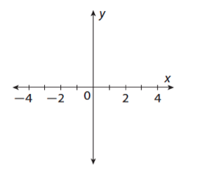

Answer Key

1. 

3. 

5. Real: 4 ; imaginary: 5

7. Real: 6 ; imaginary: -3

9. 

11. 

13. 

15. 

17. 

19. 

21. 

23. 

25. 

27. 

29. 

31. 