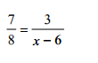HW 4-3 Continued

1. 2.

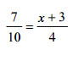

3. 4.



5. 6.





7. 8.

1. Solve the equation. State the solutions. 
2. Solve the equation. State the solutions. 
3. Solve the equation. State the solutions. 
4. It takes 1.5 hours from Tim to mow the lawn. If Kelly mows the same lawn in 2 hours, how long will it take them to mow the lawn together?

|  |
| --- |
|  |

Review:

 

 

Secondary Math III Name:_________________________________

HW 4-3 Solving Rational Equations Period:__________

**Solve each rational equation algebraically:**

