Multiplying and Dividing Rational Expressions

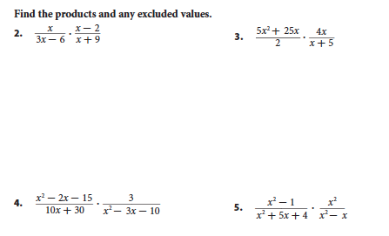

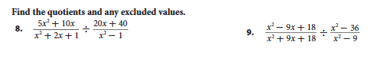

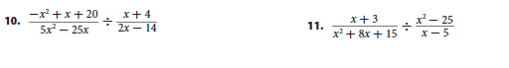

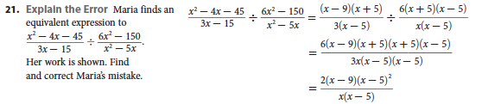

**Review**

Simplify or evaluate the following

1.  2.  3.  4.

**Selected Answers:**

3. 

5. 

9. 

11. 

17. 