**Adding and Subtracting Rational Functions**



**Simplify the given expression:**

3. 



4. 5.

**Find the LCD for each set of rational expressions**



**Add or subtract the given expressions, simplifying each result and noting the combined excluded values**

6.  7. 

 

8.  9. 





Review

State the domain and range of each function

1.  2. 

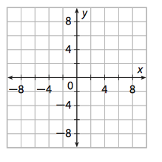Graph the following function

3. 

Selected Answers:

1. 

3. 

7. 

11. LCD: 

15. 

21. 

29. C, D, B, A