HW 6-4 Inverses Name: ________________________________

Secondary III Date: _______________ Class: ___________

Determine whether the following functions are one-to-one. If so, sketch a graph of the inverse on the same graph.

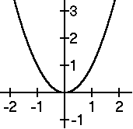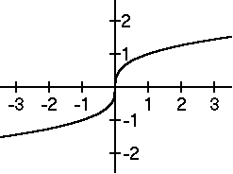

1. 2.

Find  for each of the following and state the domain of  including any inherited restrictions from f(x).

3.  4. 

5.  6. 

7.  8. 

9. Which function is the inverse of ?

a.  b.  c.  d. 

10. Which function is the inverse of 

a.  b.  c.  d. 

Review

Solve the following radical equations

1.  2. 

3. Suppose one painter can paint the entire house in twelve hours, and the second painter takes eight hours. How long would it take the two painters together to paint the house?

Selected Answers

2. Not one-to-one

4. 

6. 

10. C