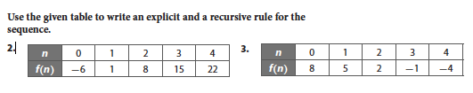

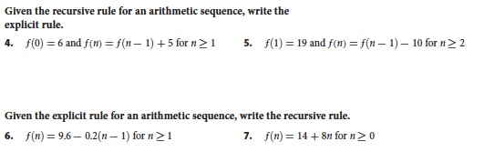



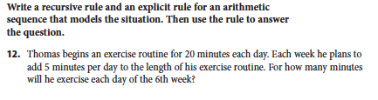

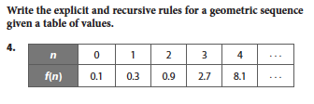

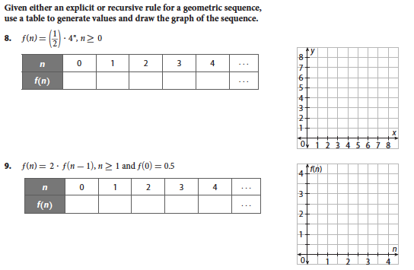



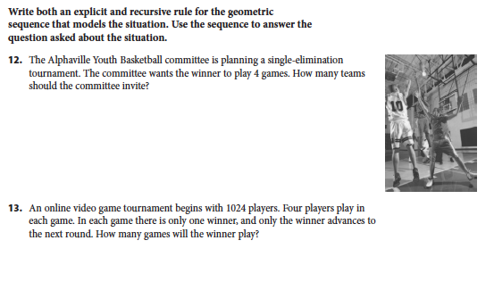

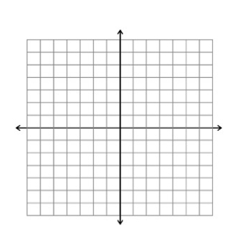**Review**

1. Sketch a graph of the following function.



2. Given the following graph, write an equation and then analyze the function

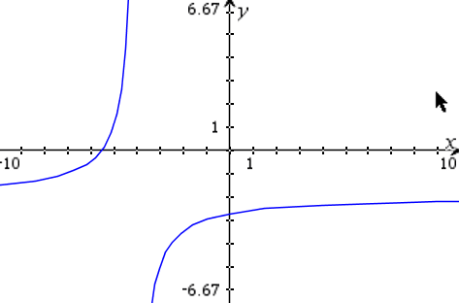g(x) =

Holes: Domain:

V Asymptote: Range:

Xint: Increasing:

Yint: Decreasing:

HEB: End Behavior:

**Selected answers:**

2. , 

4. 

6. 

12. 45 minutes

4. , 

12. 16 teams