Finite Geometric Series





**Determine how many terms the geometric series has, and then find the sum of the series.**







**11. **

**12. **

**13. **

**13. Chess** The first international chess tournament was held in London in 1851. This single-elimination tournament (in which paired competitors played matches and only the winner of a match continued to the next round) began with 16 competitors. How many matches were played?

**Review**

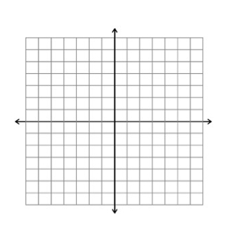

Find any holes, asymptotes, and intercepts and state the end behavior. Then sketch a graph.

1. 



2. 

**Selected Answers:**

3. 255

5. 

9. 2 – 10 + 50 – 250 + 1250 – 6250, sum = -5208

11. 1000 + 800 + 640 + 512 + 409.6 + 327.68 + 262.144, sum = 3951.424

13. 15 matches