Defining and Evaluating Logarithms

Write the given exponential equation in logarithmic form.

1.  2. 

3.  4. 

Write the given logarithm in exponential form.

5.  6. 

7.  8. 

Using a calculator, evaluate the following:





f(6).

15. Find the exact values without a calculator:

a.  b. 

c.  d. 

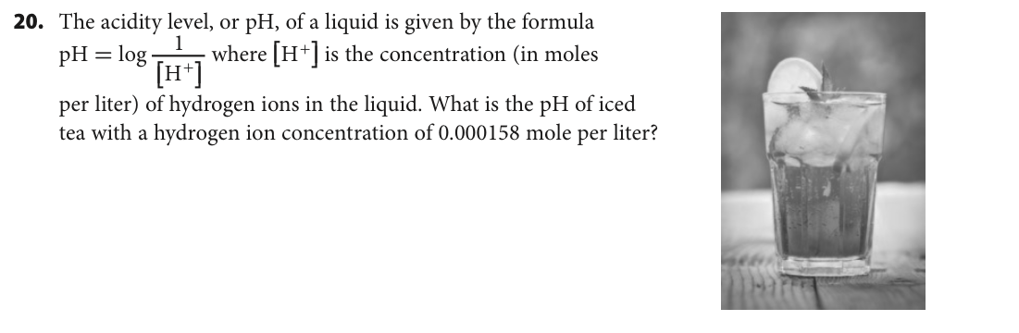

36. The loudness L, measured in decibels, of a sound of intensity x, measured in watts per square meter is . A whisper has an intensity level of  watt per square meter. How many decibels is a whisper?

Review

For the following sequences: a) Write a recursive rule, b) write an explicit rule, c) find the 10th term

1. -4, 1, 6, 11, … 2. 2, 6, 18, 54, …

Selected Answers:

5. 

8. 

14. 



15b. -2

17. 



25a. 

28. 

31. 

35. 

36. 20 dec