**Name:**

**A. Find the nearest positive and negative coterminal angles:**

1.  _________________ 4)  _________________
2.  _________________ 5)  _________________
3.  _________________ 6)  _________________

**Name:**

**B. Convert the angles from Degrees to Radians**

1)  _________________ 2)  _________________

3)  _________________ 4)  _________________

**Name:**

**C. Convert the angles from Radians to Degrees**

1)  _________________ 2)  _________________

3)  _________________ 4)  _________________

**Name:**

**D. Use the triangle to find the 6 trigonometric functions of **

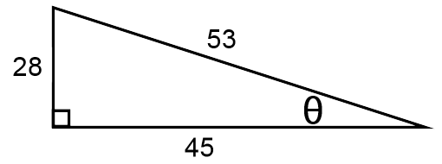

**Name:**

**E. Find the missing sides of the right triangles.**

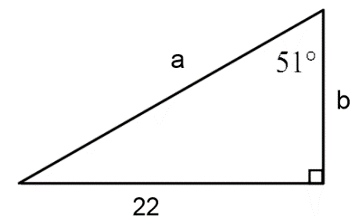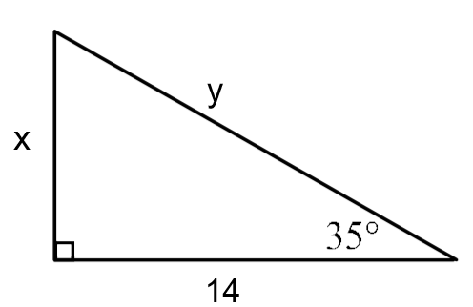

x = _________________ a = _________________

y = _________________ b = _________________

**Name:**

**F. Use the unit circle to evaluate the following**

1) _________________ 4) _________________

2)  _________________ 5)  _________________

3)  _________________ 6) _________________

**Name:**

**G. Find the amplitude, period, and shifts for each function.**

1.  2. 

Amplitude: _________________ Amplitude: _________________

Period: _________________ Period: _________________

Shifts: _________________ Shifts: _________________

**Name:**

**H. Graph the function and label the axes.**



1. Amplitude:
2. Period:
3. Shifts: