Secondary III Name _____________________

# Review Unit 1 Class _____________________

**Unit 1:**

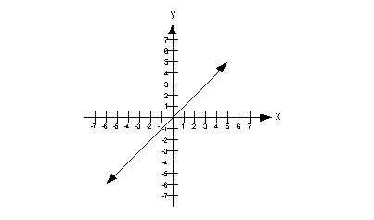**Fill in each blank with the graph that corresponds to each of the parent functions given below.**

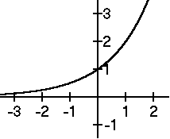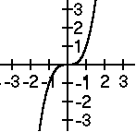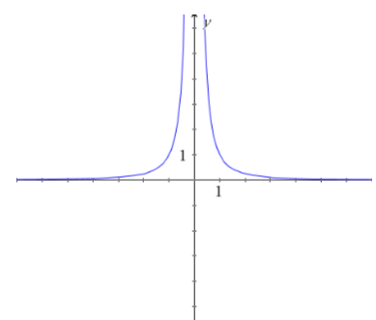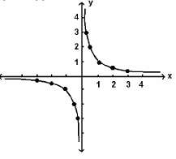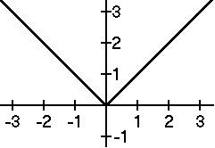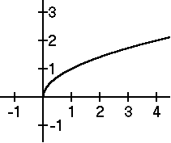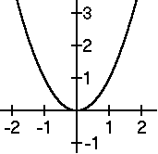

C)

F)

I)

B)

E)

H)

A)

D)

G)

1. _______
2. _______
3. _______
4. _______
5. _______
6.  _______
7. _______
8. _______
9. _______

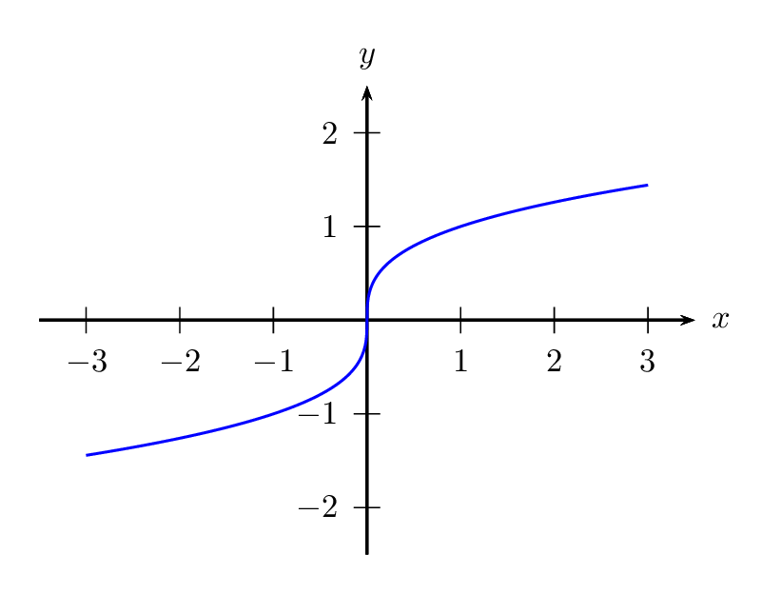

**Graph the following functions, identify the parent function, and list the transformations involved.**

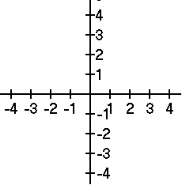10.  11.  12. 

Parent Function: _______ Parent Function: _______ Parent Function: _______

List the transformations in words: List the transformations in words: List the transformations in words:

1. ___________________ a) ____________________ a) ____________________
2. ___________________ b) ____________________ b) ____________________
3. ____________________

Domain: ________________ Domain: ________________ Domain: ________________

Range: _________________ Range: __________________ Range: _________________

x-int: __________________ x-int: ___________________ x-int: __________________

y-int: __________________ y-int: ­­­__________________ y-int: __________________

Left EB: _________________ Left EB: _________________ Left EB: _________________

Right EB: _________________ Right EB: _________________ Right EB: _________________

Inc: ____________________ Inc: ___________________ Inc: ___________________

Dec: __________________ Dec:___________________ Dec: ___________________

**Unit 2:**

1. Write the following polynomial in standard form: 

**Complete the polynomial operations and write the answers in standard form.**

2.  3. 

4.  5. 

6.  7. 

8.  9. 

**Factor the polynomial.**

10.  11. 

12.  13. 

14.  15. 

**Unit 3:**

1. Use division to determine if (x+2) or (x-6) are factors of .

2. When you divide a polynomial by (x-a), then (x-a) is a factor if the remainder equals ________.

Find allthe **zeros** and **factors** of the following functions:

3.  4. 

5.  6. 

**Given the following zeros and multiplicities, write a function in factored form:**

7. 3 (multiplicity of 2), -5, -7 8. 2, -4 (multiplicity of 5), 3 (multiplicity of 2)

**For the following functions, find the zeros, state the multiplicity of each zero and the type of intersection. State the end behavior and sketch a graph by hand.**

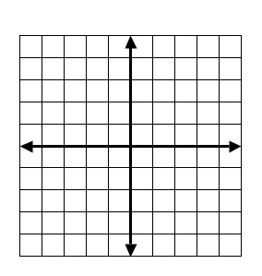

9. 

|  |  |  |
| --- | --- | --- |
| Zeros | Multiplicity | Intersection |
|  |  |  |
|  |  |  |

End Behavior:

10. 

|  |  |  |
| --- | --- | --- |
| Zeros | Multiplicity | Intersection |
|  |  |  |
|  |  |  |
|  |  |  |

End Behavior:

**For the following functions, graph on your calculator, state the zeros and multiplicity, write in factored form and analyze.**

11. 12. 

|  |  |  |
| --- | --- | --- |
| Zeros | Multiplicity | Intersection |
|  |  |  |
|  |  |  |
|  |  |  |

|  |  |  |
| --- | --- | --- |
| Zeros | Multiplicity | Intersection |
|  |  |  |
|  |  |  |
|  |  |  |

Factored form: Factored form:

End Behavior: End Behavior:

**Find the zeros on the graph, then write the function in factored form**. 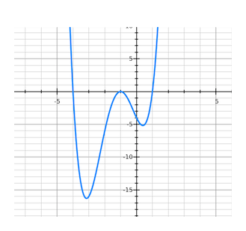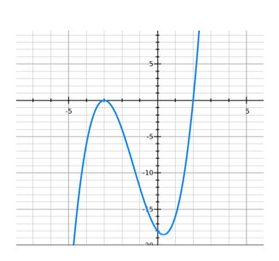

13. 14.

Zeros: Zeros:

Factored Form: f(x)= Factored Form: f(x)=

**Unit 4:**

**Perform the indicated operation and state the excluded values**

1.  2. 

3.  4. 

5.  6. 

7. 

**Solve the equations using Cross Multiplication:**

8.  9. 

**Solve the equation using “Kill the Denominator:”**

10.  11. 

**Unit 5:**

**List the transformations and graph the following:**

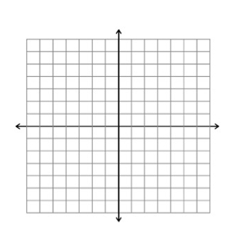1.   2. 

Transformations: Transformations:

**Use division to put into transformation form, then list the transformations** **from** 

3.  4. 

**For the following functions, identify the holes, asymptotes, and intercepts.**

5.  6. 

Holes: Holes:

V.A.: V.A.:

H.A.: H.A.:

x-int: x-int:

y-int: y-int:

**Find the information for the functions, then graph.**

7. 

Domain:

Range:

x- int:

y-int:

Vertical Asymptote:

Horizontal Asymptote:

End Behavior:



8. 

Domain:

Range:

x- int:

y-int:

Vertical Asymptote:

Horizontal Asymptote:

End Behavior:

9. 

Domain:

Range:

x- int:

y-int:

Vertical Asymptote:

Horizontal Asymptote:

End Behavior: