Secondary Math III Name:_________________________________________

Unit 11 Review Period:_______

**Find the exact value.**

4. 5. 6. 7.



**Using the law of sines, find the missing side of the triangle:**

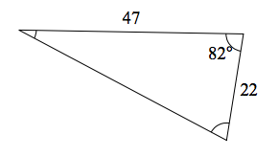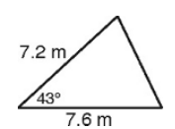

x

8. 9.

x

**Solve the following triangles (find ALL angles and sides)**

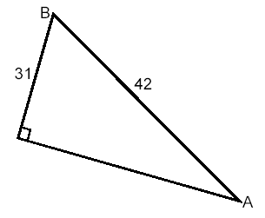

11.

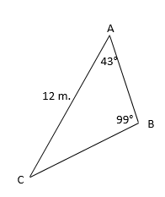

12.



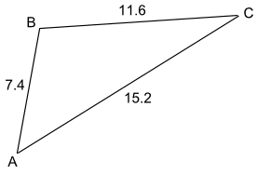

13.



14. Solve given a=55, =350 and





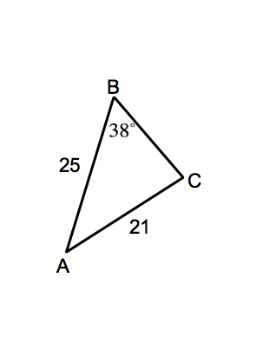

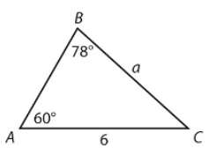15. Find c 16. Find A

17. Given a=12, b=14, c=8, find C 18. Given, b=13 and c=11, find B

19. Farmer Jones owns a triangular piece of land. The length of the fence AB is 150 m. The length of the fence BC is 231 m. The angle between fence AB and fence BC is 123º.How much land does Farmer Jones own?

20. To approximate the [length](javascript:def('/Glossary/glossaryterm.aspx?word=Length',%20500,%20500);) of a lake, a surveyor starts at one end of the lake and walks 245 yards. He then turns 70º and walks 270 yards until he arrives at the other end of the lake. Approximately how long is the lake?

21. Marcy flies her kite at a 45 angle from the ground. The kite string is approximately 235 feet long. Another person on the other side of the park tangles his kite with Marcy’s. If the other person is flying his kite at a 72angle, what is the approximate distance between Marcy and the other person?

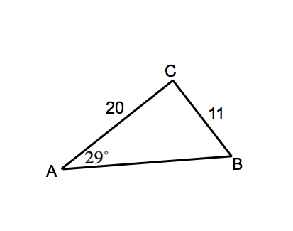

*Honors Only*

22. Solve the Triangle