Secondary Math III Name:_________________________________________________

Unit 11 Review Period:___________

**Convert the radical to exponent form and vice versa:**

1.  2.  3.  4. 

**Simplify the following. Give *exact* answers:**

5.  6.  7.  8. 

9.  10.  11.  12. 

13.  14. 

**Solve the following equations, check for extraneous solutions:**

15.  16.  17. 

18.  19.  20. 

21.  22. 

23.  24. 

**Write the transformations from the parent function and state the domain and range:**

25.  26. 

27.  28. 

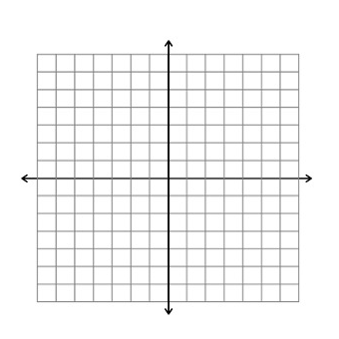**Graph the following and state the domain and range:**



29.  30. 

31.  32. 

**Write the equation for the following graphs:**

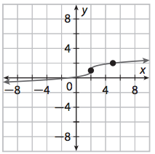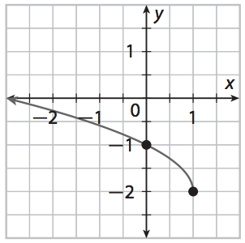

33. 34.

36. For a spinning amusement park ride, the velocity in meters per second of a car moving around a curve with a radius *r* meters is given by  where *a* is the cars acceleration in m/s2. If the ride has a maximum acceleration of 25 m/s2 and the cars on the ride have a maximum velocity of 10 m/s, what is the smallest radius that any curve on the ride may have?